**AWS IAM Assignment**

1. Create a new IAM user with programmatic access only and generate an access key and secret access key.  
   A picture containing text, screenshot, font

   Description automatically generated
2. Create an IAM policy that allows the user to read and write to an S3 bucket and attach it to the user.  
   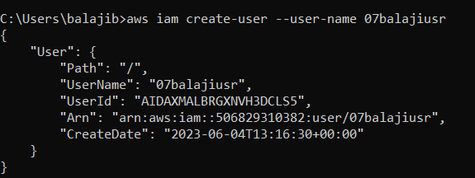  
     
   A picture containing text, screenshot, font

   Description automatically generated  
     
   A computer code on a black background

   Description automatically generated with low confidence  
     
   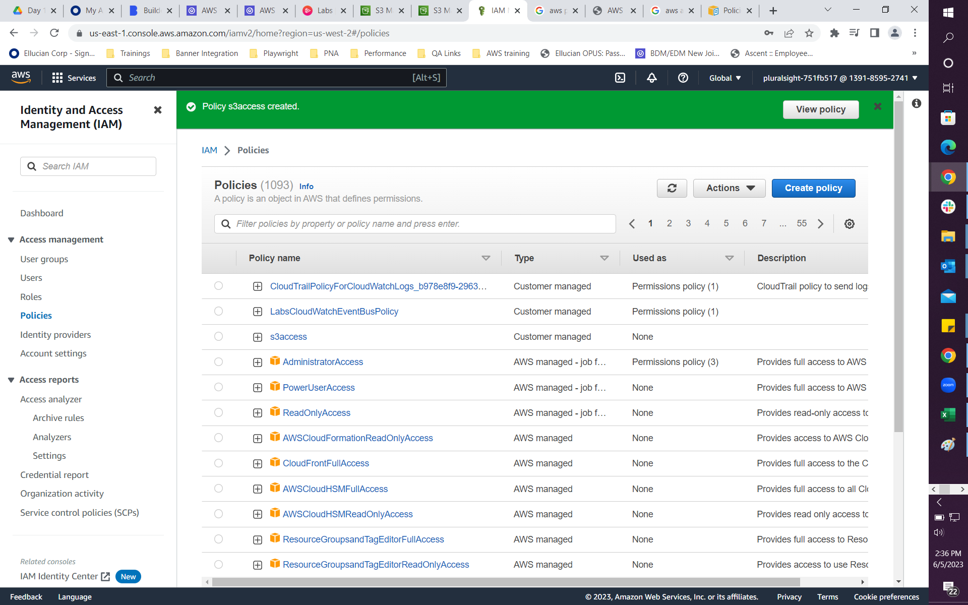  
   A screenshot of a computer

   Description automatically generated
3. Create an IAM group and add the user to it. Launch an EC2 instance and assign the IAM role to it.

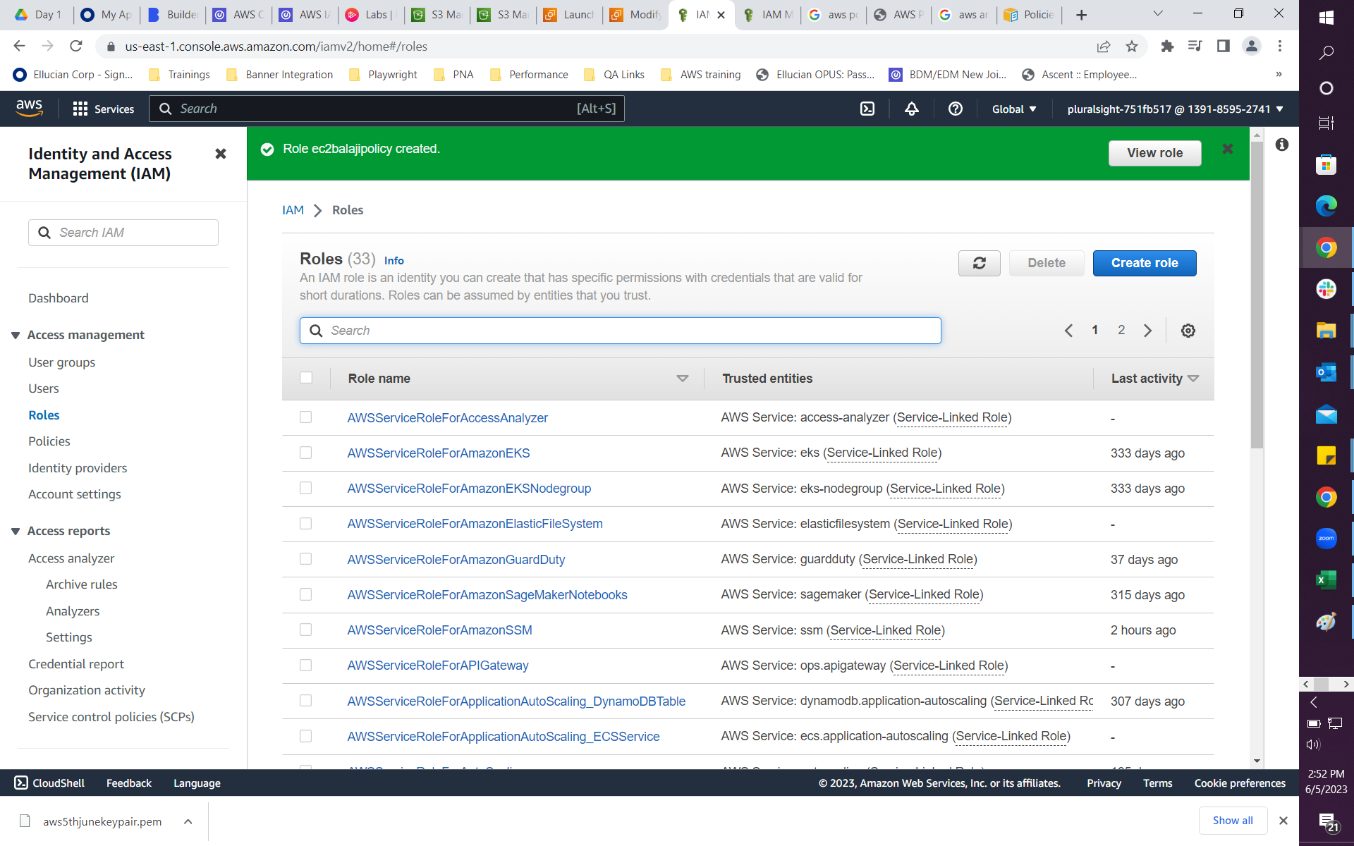

1. Create an IAM policy that allows read-only access to an S3 bucket and attach it to a group.

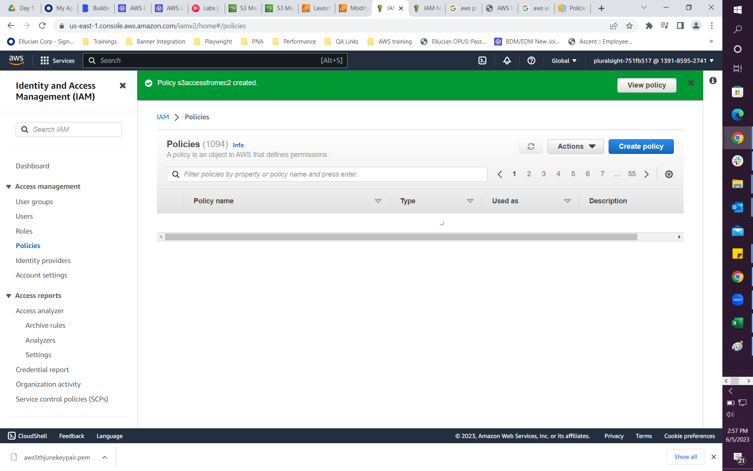  
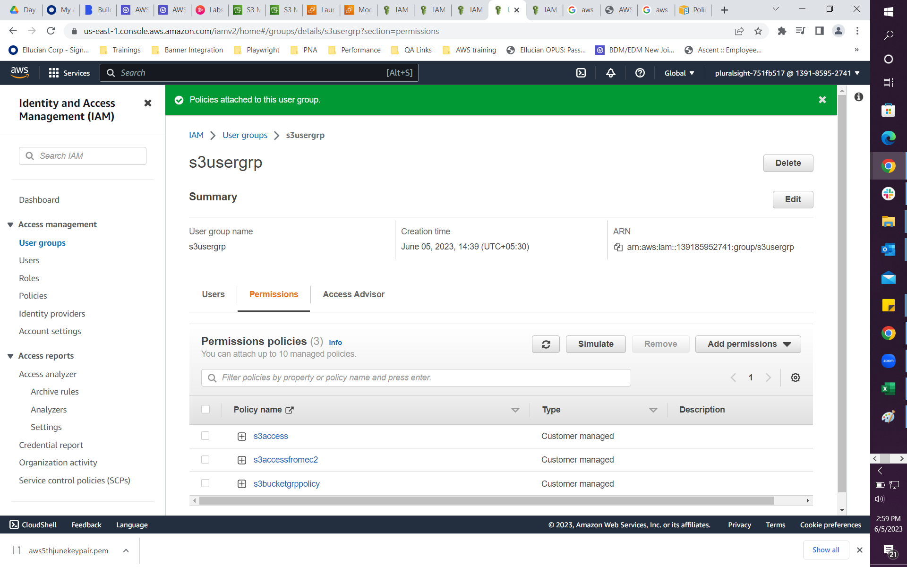

1. Create an IAM policy that denies access to an S3 bucket and attach it to a user, group, or role.  
     
   

